G-1-4 八大詞類-進階 學習單

活動：
請判別下面例句中畫線部分分別屬於何種詞性？

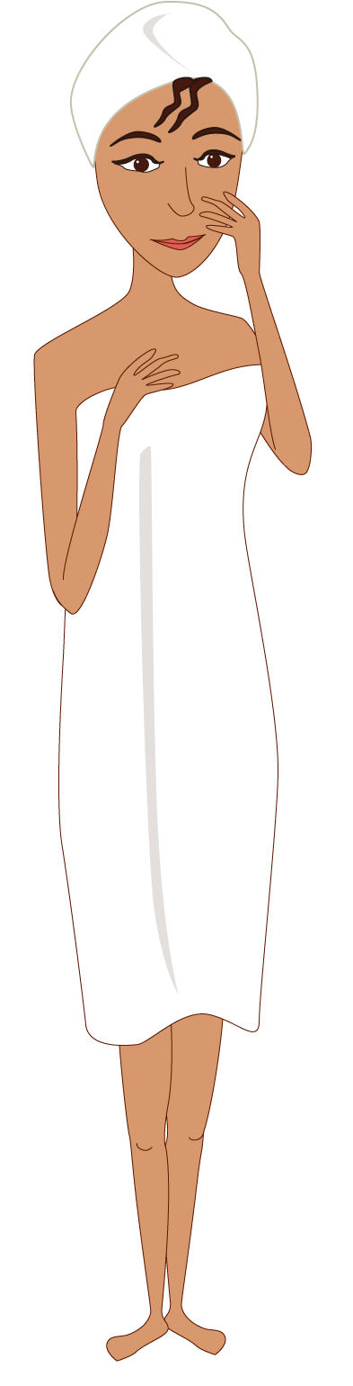

 A woman with dark skin is in the bathroom.
 Wow! She only wears a bath towel.
 Besides, she wraps her hair up in a towel.
 She often uses toner after she takes a shower.
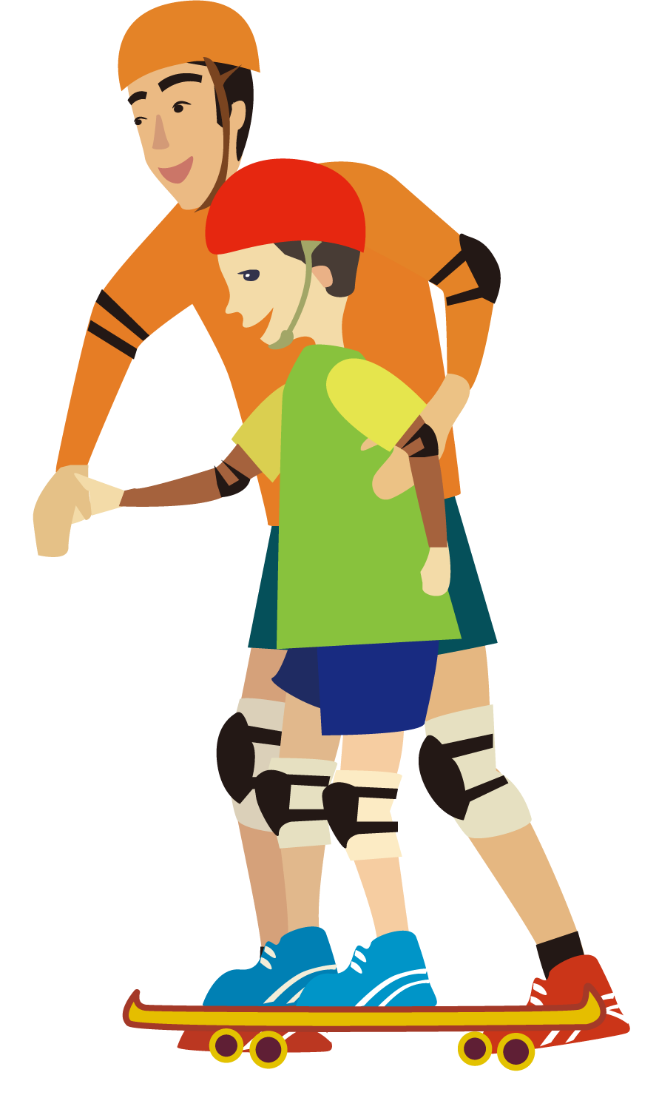

 A boy is learning skateboarding.
 His father is standing by him.
 With his father’s help, the boy can stand
upright.
 Both of them are very happy.

名 詞:
代名詞:
動 詞:
形容詞:
副 詞:
介係詞:
連接詞:
感嘆詞:

Ans:

名 詞: woman, towel, skateboarding, hair, father, help
代名詞: She, Both
動 詞: wears, takes, stand, is
形容詞: dark, happy, a
副 詞: in, Besides, up, often
介係詞: by, in, of, With
連接詞: after
感嘆詞: Wow

