G-1-5 八大詞類-挑戰 學習單

活動：
請依提示與圈圈內的字，協助Pinocchio完成他的奇遇記。
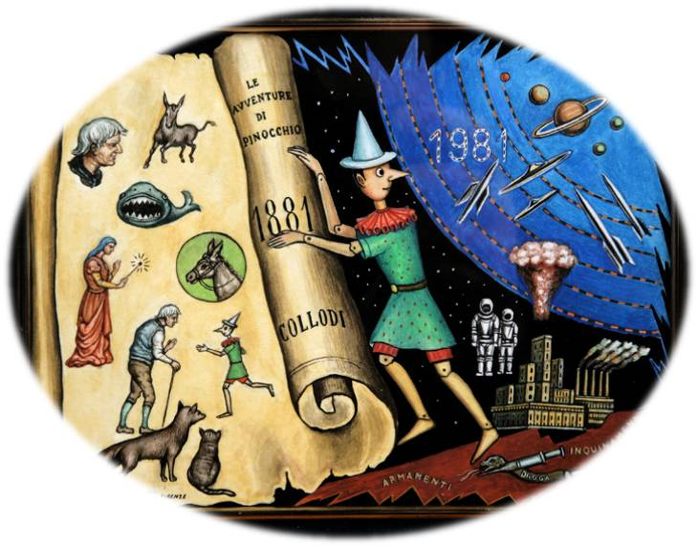
lived
He
real
when
fairy
ticket
Inside
bigger
by
and
you
again
sneezed

Long ago, there (動詞) a lonely old carpenter named Geppetto. (代名詞) made a puppet with wood, a ball, and a string. That night, a (名詞) visited and cast a spell that made the puppet walk and talk. The next morning, Geppetto found something, “ ! (感歎詞) The puppet could move! ”. He named the puppet Pinocchio. Geppetto gave Pinocchio all of his money and sent him into town to buy books for school. (副詞), Pinocchio used the money to buy a
(名詞)for the circus. Two clowns gave Pinocchio a hat and asked him to stay, but he said he had to go back to Geppetto.

The clowns returned Pinocchio’s money, but on the way home he was robbed by an evil cat and an equally evil fox. The fairy appeared again (連接詞) asked what happened; Pinocchio pretended he had been captured by a monster. Suddenly, his nose grew, and the fairy said, “Whenever (代名詞) lie, your nose will get
(形容詞). Now go find Geppetto; he is out looking for you (介系詞) the sea.”

Pinocchio was rowing a small boat in the sea (連接詞) he thought he heard Geppetto’s voice coming from inside a large dark cave. He rowed inside, only to find himself (介系詞) a whale with Geppetto. He tickled the whale with a feather, and the whale (動詞), sending Pinocchio and Geppetto flying out onto the beach. Feeling relieved, Pinocchio vowed never to lie (副詞). That night, the fairy gave Pinocchio a present - he became a (形容詞) boy then.

木偶圖片：http://it.wikipedia.org/wiki/File:Allegoria_Pinocchio_Dughetti.jpg
Ans:

活動：
Long ago, there lived a lonely old carpenter named Geppetto. He made a puppet with wood, a ball, and a string. That night, a fairy visited and cast a spell that made the puppet walk and talk. The next morning, Geppetto found something, “Wow! The puppet could move!”. He named the puppet Pinocchio. Geppetto gave Pinocchio all of his money and sent him into town to buy books for school. Instead, Pinocchio used the money to buy a ticket for the circus. Two clowns gave Pinocchio a hat and asked him to stay, but he said he had to go back to Geppetto.

The clowns returned Pinocchio’s money, but on the way home he was robbed by an evil cat and an equally evil fox. The fairy appeared again and asked what happened; Pinocchio pretended he had been captured by a monster. Suddenly his nose grew, and the fairy said, “Whenever you lie, your nose will get bigger. Now go find Geppetto; he is out looking for you by the sea.”

Pinocchio was rowing a small boat in the sea when he thought he heard Geppetto’s voice coming from inside a large dark cave. He rowed inside, only to find himself inside a whale with Geppetto. He tickled the whale with a feather, and the whale sneezed, sending Pinocchio and Geppetto flying out onto the beach. Feeling relieved, Pinocchio vowed never to lie again. That night, the fairy gave Pinocchio a present - he became a real boy then.

